Quick Guide to Getting Started:
Your login name is your guest name. Don’t use anything personal
http://portaportal.com

To visit as a guest to view someone else’s portal:
- Go to www.portaportal.com
- Type the Guest Name in the Guest Access Box (rozauer or rozauer2) or afasano,
- Click Visit

- Sign up – YOUR USER NAME IS THE NAME YOUR STUDENTS WILL USE TO ACCESS YOUR PORTAPORTAL
- [Keep a record of your portaportal login name and password]
- You will automatically be connected to your portal. (You will receive an email to confirm the site)

- Add categories 
Begin by entering up to five categories of your choice. You can divide your portal by class or by subject or strand. You can add more categories as needed.

- Set preferences 
Tailor the details of your portal to your taste. On the preferences page you can change the colors, layout, greetings and many other decorations.
You must set the guest behavior to “allow guest access”.
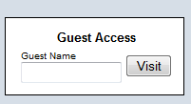
- Share your portal
Once you're ready to share your portal just tell your students the login name.

Add categories

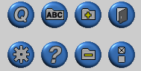
Quick add button

Preferences

Delete categories

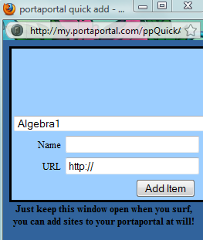
Use the quick link option as you search for new sites to add to your portal. It will be available whenever you are searching the web and you can enter a link into any category or sub-category on your portal without going back to the portal.

- To edit links you've already entered click on the button that looks like this:

Add links
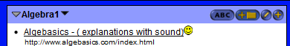
Add sub-categories
EDIT

