Name ________________________ Period ______ Date ____________

Geometry Unit 3 Model Curriculum Assessment

1.
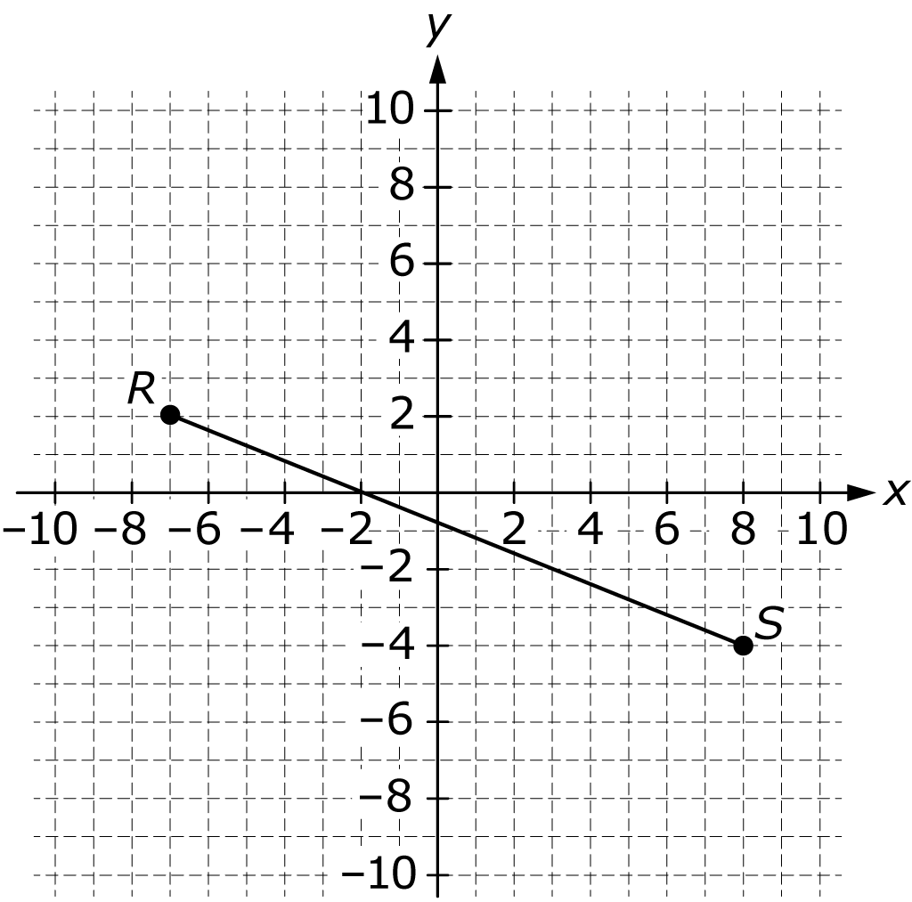

On the directed line segment from R to S on the coordinate plane above, what are the coordinates of the point that partitions the segment in the ratio 2 to 3 ?

2.
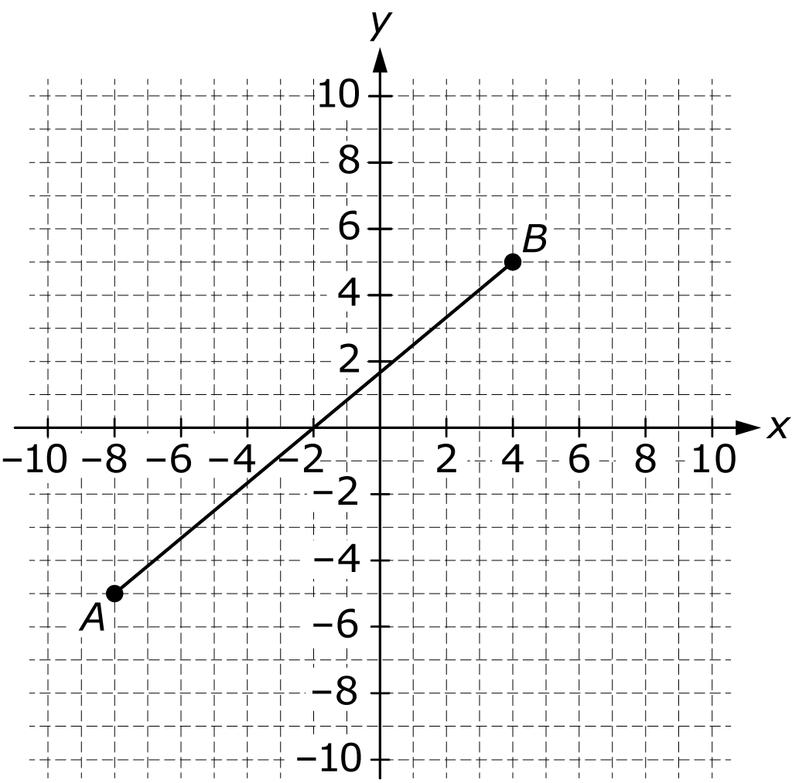

On the coordinate plane above, represents a walking path in a park. Lights have been installed at the locations represented by points A and B. The park manager wants to place two additional lights at equal intervals from A to B. What are the coordinates of the points that represent where the new lights should be placed?

3. Point P lies on the directed line segment from to and partitions the segment in the ratio 2 to 1. What are the coordinates of point P ?

4. Point R lies on the directed line segment from to and partitions the segment in the ratio 3 to 5. What are the coordinates of point R ?

5.
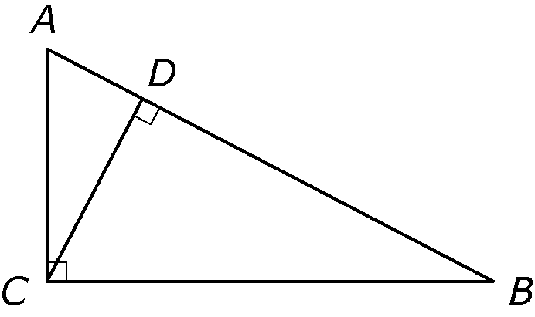

In right triangle ACB above, is perpendicular to Complete the proof that by providing a reason for each statement in the table below.

Statements | Reasons
Triangle ACB is a right triangle.
is a right angle.
is perpendicular to
and are right angles.
and
and
and
6.
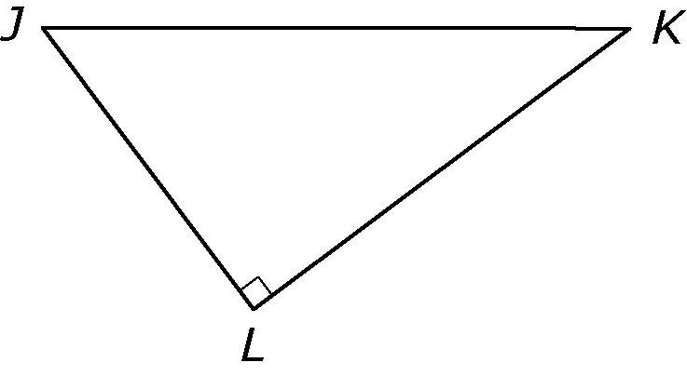

Triangle JKL above represents the boundary of a state wilderness area. An access road will be constructed that intersects side JK at a 90 degree angle and extends to point L. The road will intersect side JK 24 miles from point K, and the length of side KL is 30 miles.

Part A: What is the length, in miles, of the access road? Show your work.

Part B: What is the length, in miles, of side JK ? Show your work.

Part C: What is the length, in miles, of side JL ? Show your work.
7.
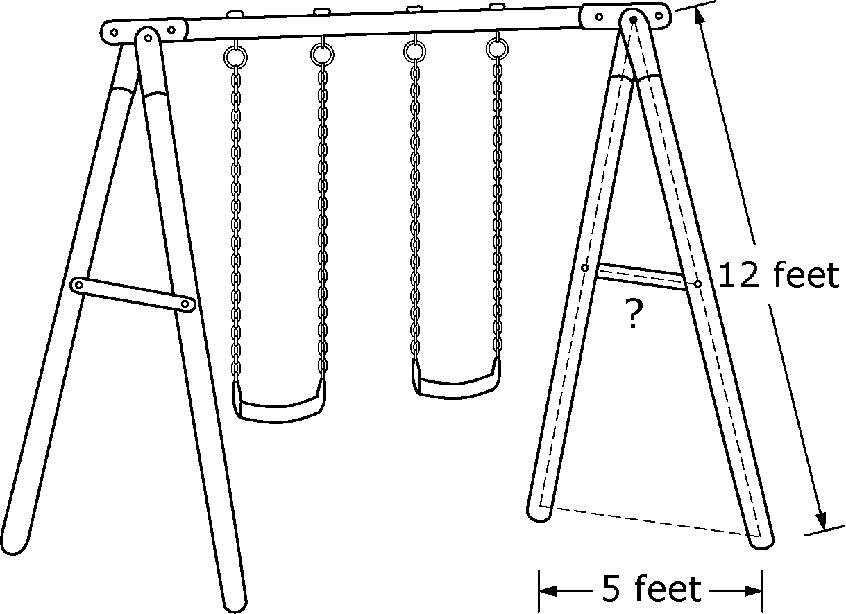

The figure above represents a swing set. The supports on each side of the swing set are contructed from two 12-foot poles connected by a brace at their midpoint. The distance between the bases of the two poles is 5 feet.

Part A: What is the length of each brace?

Part B: Which theorem about triangles did you apply to find the solution in Part A?
8. Answer Parts A–D below to complete some aspects of the proof that the medians of a triangle meet at a point.

Without loss of generality, we can assume that the vertices of the triangle are at the points and as shown below.

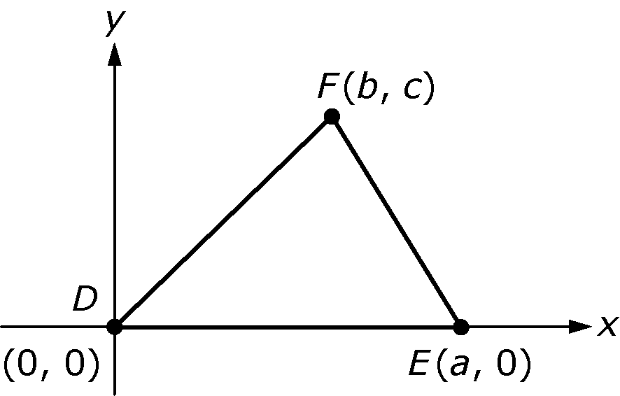

Then the midpoints of and can be labeled as and respectively, as shown.

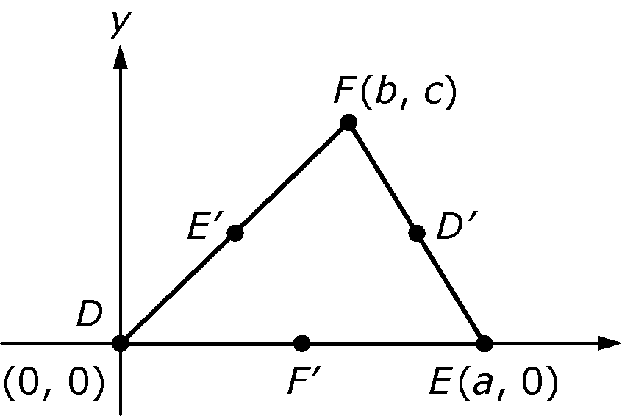

Part A: It can be shown that the coordinates of are and the coordinates of are What are the coordinates of in terms of a, b, and c ?

Part B: Based on your answer to Part A, what is the slope of in terms of a, b, and c ?

Part C: Based on your answer to Part B, what is the equation of

Part D: It can be shown that and intersect at the point Show that is also a point on

9.
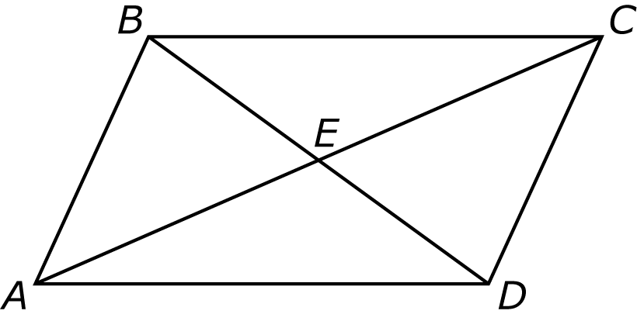

Refer to parallelogram ABCD above. Complete the proof that segment AC and segment BD bisect each other by providing the missing statements or reasons in the table below.

Statements | Reasons
 | Given
 | Corresponding parts of congruent triangles are congruent
 | Definition of midpoint
Segment AC and segment BD bisect each other

10. To find the height of a lamppost at a park, Rachel placed a mirror on the ground 20 feet from the base of the lamppost. She then stepped back 4 feet so that she could see the top of the lamp post in the center of the mirror. Rachel's eyes are 5 feet 6 inches above the ground. What is the height, in feet, of the lamppost?

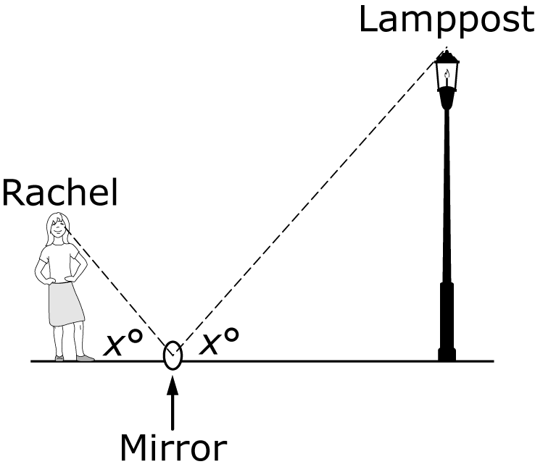

11. In trapezoid ACDE below, is congruent to the length of is and angle A is a right angle. What is the area of trapezoid ACDE ?
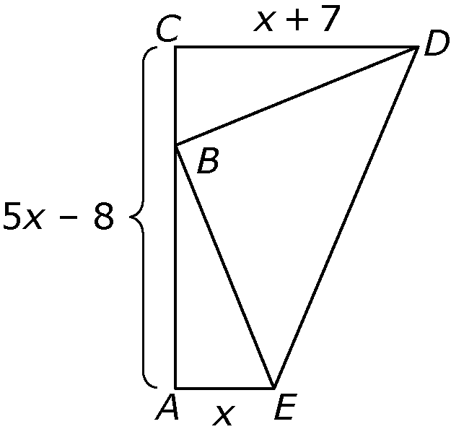

12.

The equation above represents the display on a calculator in degree mode. Use right triangles to explain the meaning of the equation and why it can be applied to any size right triangle with a angle.

13.
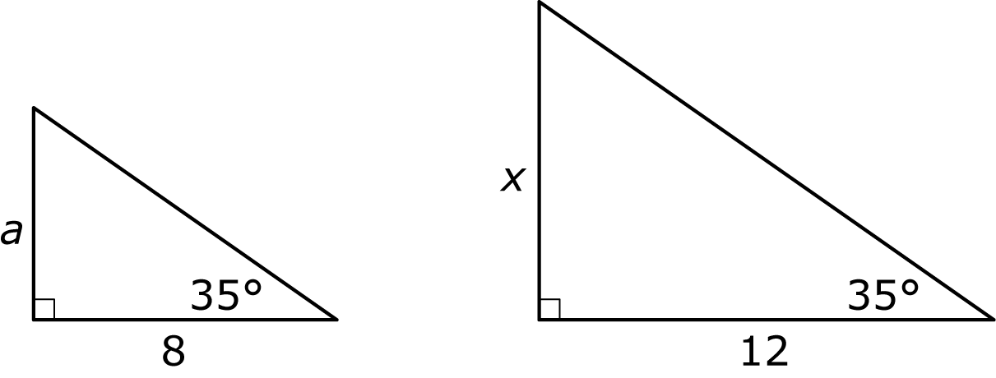

For the two right triangles above, explain why What trigonometric ratio is also equal to the two given ratios?

14.
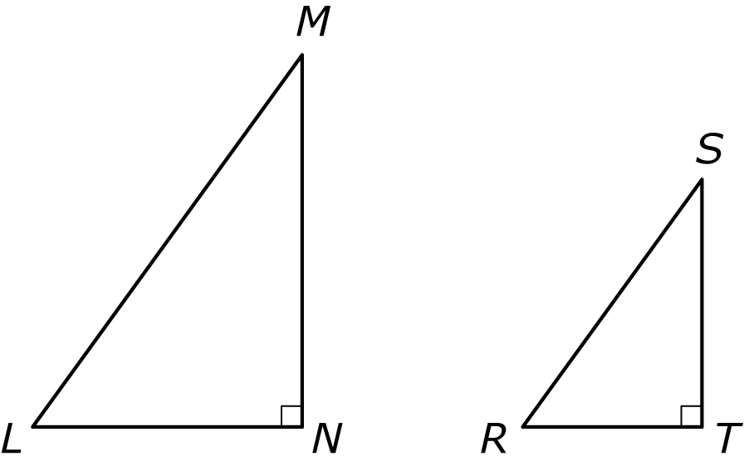

In the right triangles above, For each ratio of side lengths in the table below, use the right triangles to identify another ratio of side lengths that is equal to the given ratio and all sine, cosine, or tangent ratios that are also equal to the given ratio.

 | Side Ratio | Trigonometric Ratios

15. If angle X and angle Y are complementary angles, which of the following must be true?

a.

b.

c.

d.

Explain your answer using words and figures.

16.

The figure above represents a plan for a wheelchair ramp to a step that has a height of 10 inches. Jodi and Kevin each used right-triangle trigonometry to determine the length of the ramp. Both solutions are shown below. Explain why both solutions resulted in the same answer.

Jodi’s solution | Kevin’s solution

17.
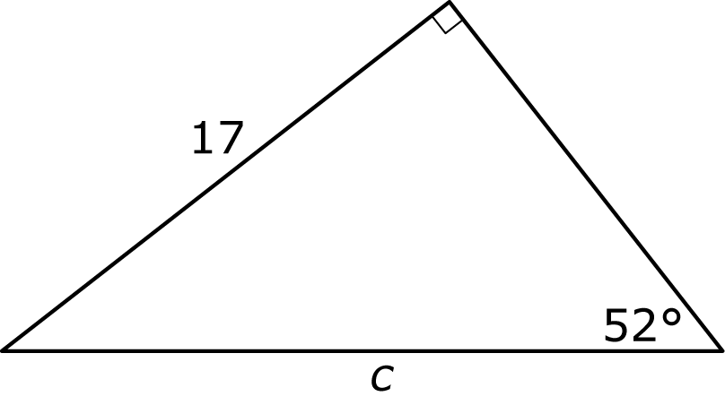

In the figure above, Based on the figure, which of the following equations is also true?

a.

b.

c.

d.

18. A 12-foot ladder that is leaning against a wall makes a angle with the level ground. Which of the following equations can be used to determine the height, y, above the ground, in feet, that the ladder touches the wall?

a.

b.

c.

d.
19.
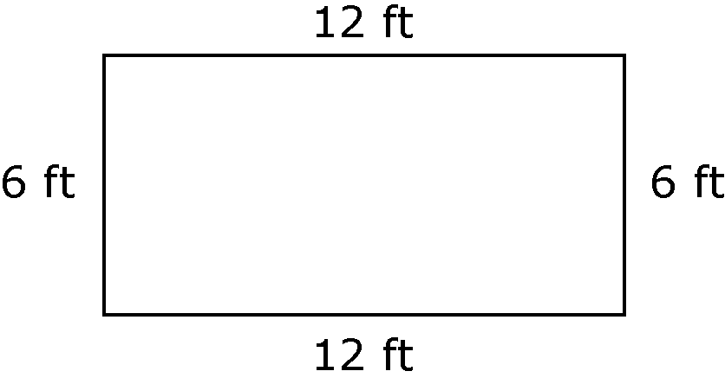

The figure above represents a plot of land that Susan has measured to use as a fenced garden. Before she builds the fence, she wants to make sure that the plot is rectangular. She measures the length of one of the diagonals. If Susan’s plot is rectangular, what will be the length, in feet, of the diagonal she measured?

20. The diagram below shows a model of a staircase in which all the riser heights are equal and all the tread lengths are equal.

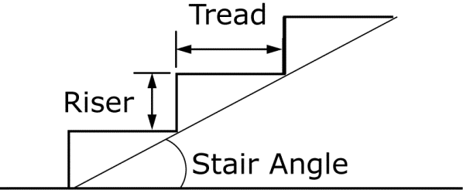

A carpenter wants to build a staircase in which each riser has a height of 6 inches and each tread has a length of 11 inches. Which of the following expressions is equal to the stair angle?

a.

b.

c.

d.

21. Use trigonometry to show that a formula for the area of below is

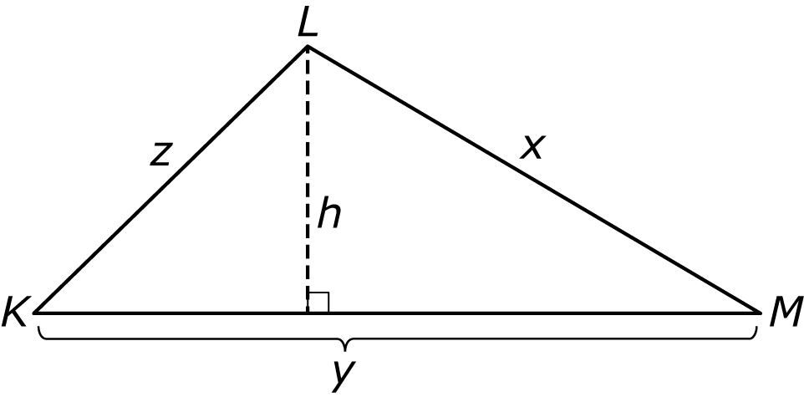

22. Which of the following expressions can be used to find the area of the triangle below? Select all that apply.

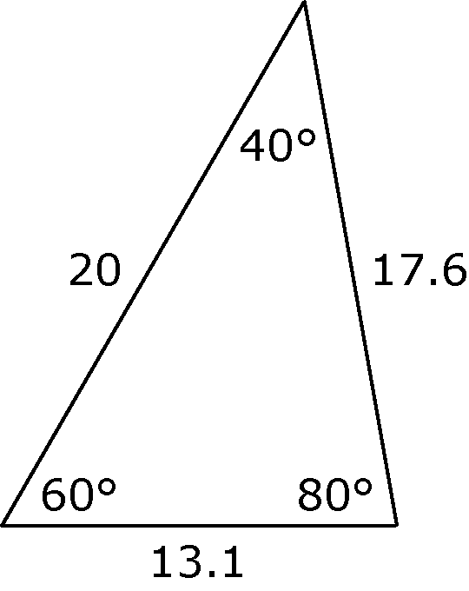

Can Be Used

23.
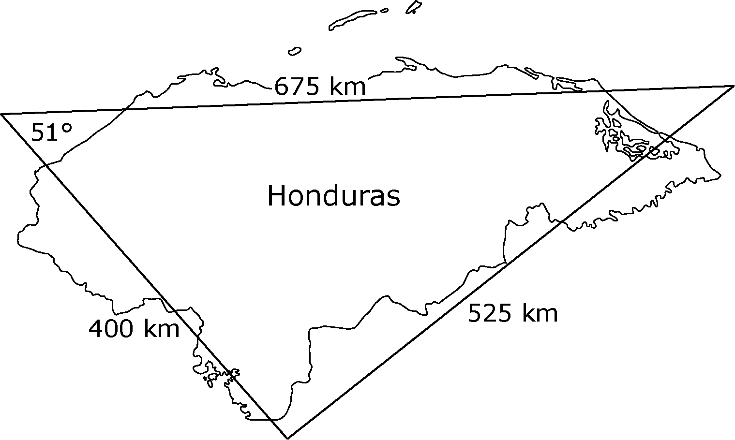

The figure above shows a triangle drawn over a map of Honduras. Use the measurements of the triangle to approximate the area, in square kilometers, of Honduras. Show your work.

24.
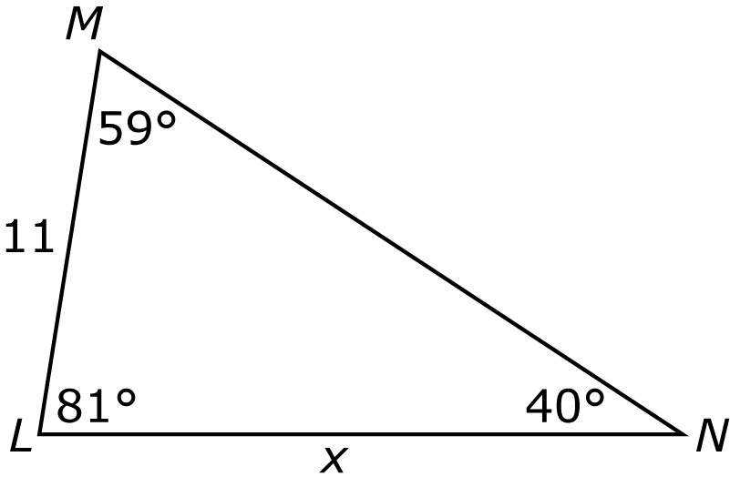

For above, determine whether the Law of Sines or the Law of Cosines is the best method to find the value of x. Do not solve for x. Justify your answer.

25.
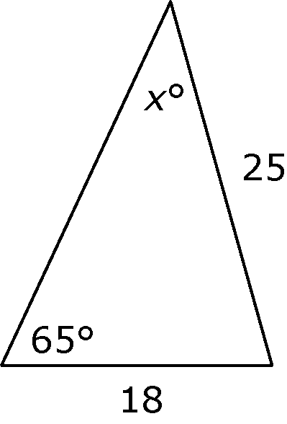

Which of the following expressions gives the value of x in the triangle above?

a.

b.

c.

d.

26. Refer to the triangle below. Use the altitude to show why

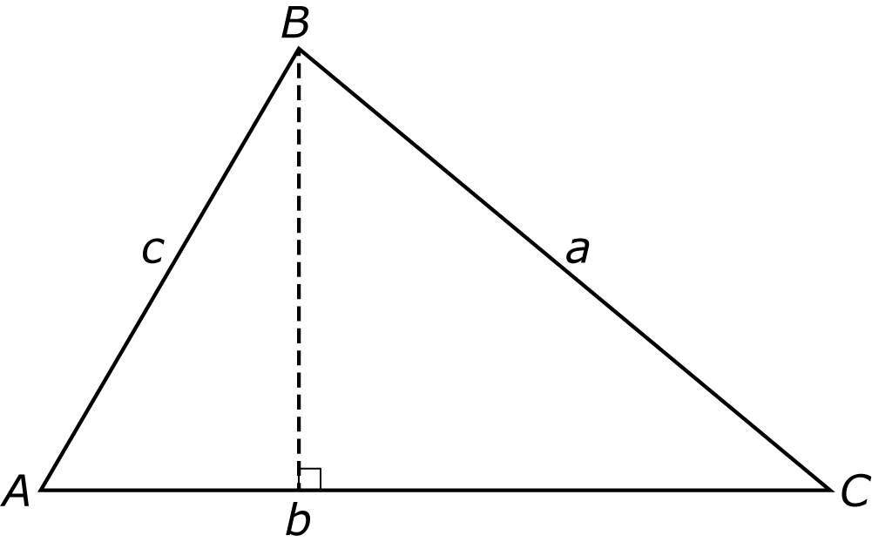

27. The three sides of a triangle have lengths 20, 25, and 40. Which of the following expressions gives the measure of the largest angle of the triangle?

a.

b.

c.

d.

